* Take a *picture* (not a screenshot) showing your laptop with the radio connected and the spectrum waterfall on your computer
* Tune to the local radio station, 103.1 MHz. What is the normal bandwidth of an FM radio station? Include this answer in your submission after the picture.
* Modify the bandwidth to 1/4 of the “normal” bandwidth. What happens? Include the question answer and a screenshot of your modification in your answer.
* There is a weather radio tower outside of Arlington. You may need to go outside to pick it up. It doesn’t use the WFM setting of SDRSharp (or wideband FM in other software). Why is this? What is the difference? Show the website you found the Arlington weather radio frequency on and submit a screenshot of the signal you receive from it.

1.Image:

2. 200 KHz

3. the signal is garbage/ gibberish / static (image is on a 4k monitor, sorry the image is huge)

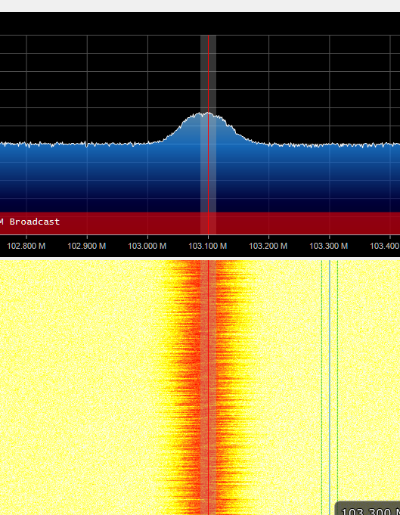

4. <http://www.nws.noaa.gov/nwr/coverage/site2.php?State=SD&Site=KXI71>

<https://www.fcc.gov/general/narrowbanding-overview>

The weather broadcast station uses narrowband frequencies, not wide-band frequencies (WFM)

Which is basically the same Just a less Bandwidth, lower quality channels but room for more of them – audio quality isn’t their designed purpose unlike the lower frequency wide-band stations.

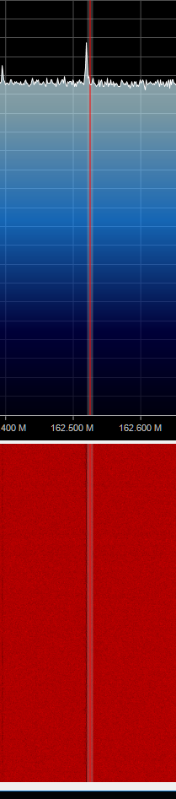 (from my window, it might be weaker beause of that)